Experiment 1: Kanban Board to Visualize Tasks
Course code: CSA1006
Course: Software Engineering
Name: B. Pavani
Register No: 192525248
Tool Used: Jira

Aim
To create a Kanban board in Jira with the columns To Do, In Progress and Done, add at least 5 sample tasks, and move the tasks across the columns to simulate a workflow.

Software Used
Jira Software, https://www.atlassian.com/software/jira

Procedure

Step 1: Sign up / Log in to Jira
Open https://www.atlassian.com/software/jira in a browser, click "Get it free" and sign up with an email address (or log in with an existing Atlassian account). Enter a site name when asked.

Step 2: Create a Kanban project
Click "Create" and choose "Space" (project), select the Kanban template and click "Use template". Enter the project name "Exp-1:kanban" and the key "KAN", then click "Create".

Step 3: Open the Kanban board and check the columns
Open the project and click the "Board" tab. The board shows the columns To Do, In Progress and Done (Jira also adds an In Review column by default).

Step 4: Create the sample tasks
In the To Do column click "+ Create", type the task name ("What needs to be done?") and press Enter. Add the five tasks listed in the table below. Jira numbers them KAN-1 to KAN-5.
Issue | Task Name | Purpose
KAN-1 | Design the login page | Design the user login screen
KAN-2 | Create the Home Page | Build the home page of the application
KAN-3 | Develop User Registration | Code the user registration module
KAN-4 | Test Login Functionality | Test that the login works correctly
KAN-5 | Prepare Project Documentation | Write the project documentation

Step 5: Move the tasks across the columns
Drag and drop each card to the column that matches its progress. KAN-3 (Develop User Registration) was dragged from To Do to In Progress, and KAN-1 (Design the login page) was dragged through In Progress to Done. KAN-2, KAN-4 and KAN-5 remain in To Do, and the In Review column has no tasks.
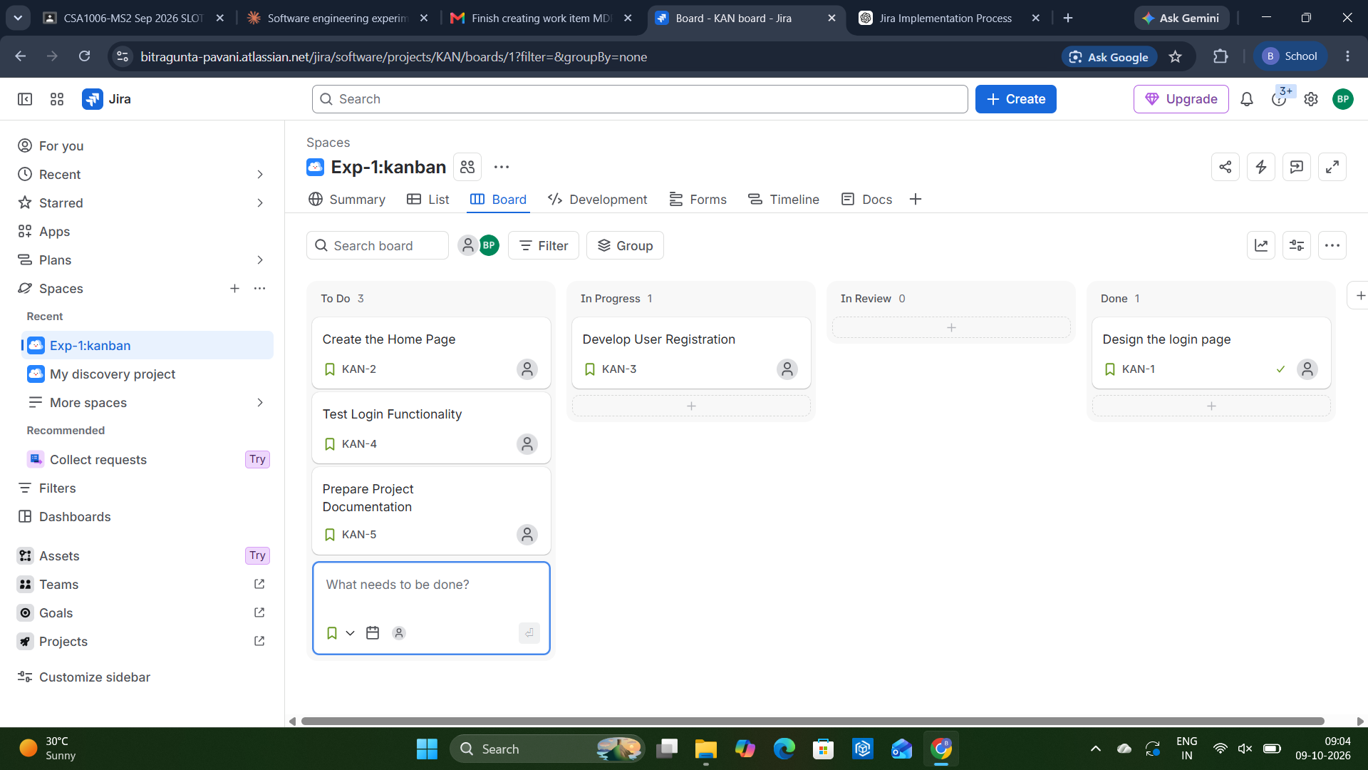
Figure 1: Kanban board in Jira after moving the tasks across the columns

Workflow Simulation Summary
Stage | To Do | In Progress | In Review | Done
Initial | KAN-1 to KAN-5 | - | - | -
After moving tasks | KAN-2, KAN-4, KAN-5 | KAN-3 | - | KAN-1

Result
A Kanban board with the columns To Do, In Progress and Done was successfully created in Jira. Five sample tasks were added and moved across the columns, which visualized the task workflow of a software project.

